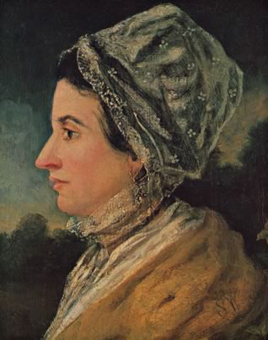
WHAT: MWiB QUIET DAY
INSPIRATIONAL WOMEN
WHERE: ERDINGTON METHODIST CHURCH
1, Wesley Road. Birmingham. B236TX
WHEN. MARCH 28th 10.30am -3.30pm
WHO. DR JILL BARBER
Director of Englesea Brook Primitive
Methodist Museum

