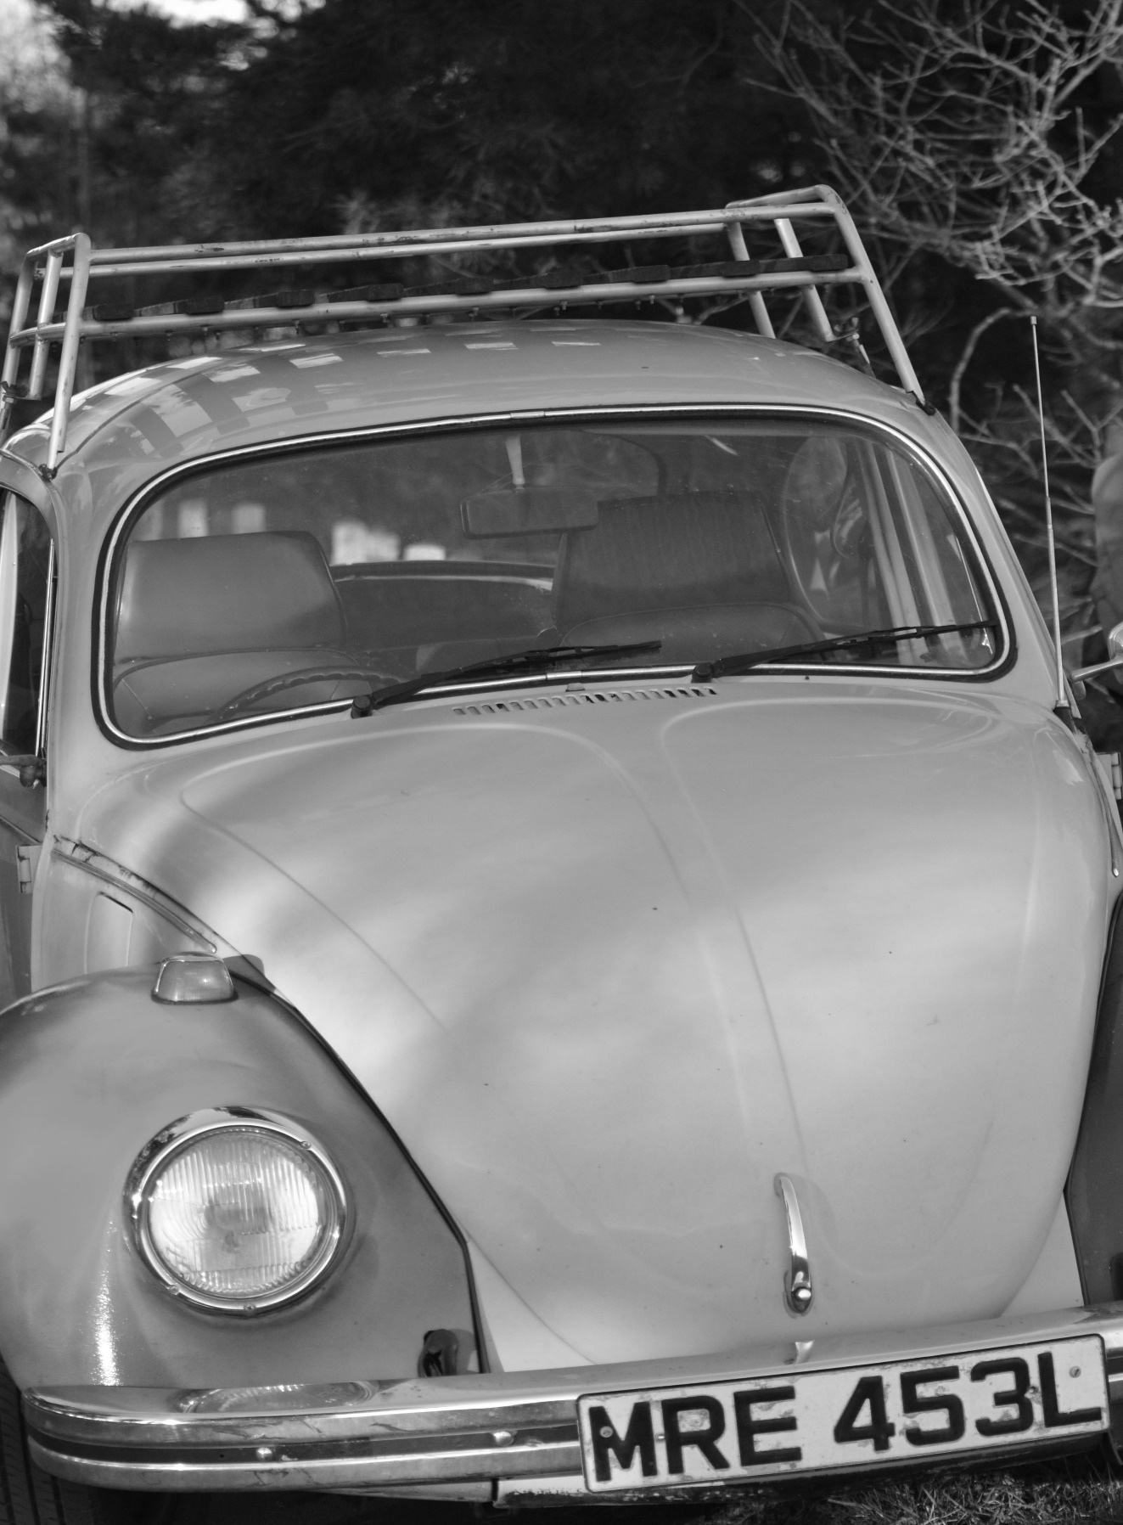
Transport Fayre
Kingstanding Methodist Church (Kings Road)

Saturday 2nd June
11am to 3pm
Entry and first burger free

For information contact 07794639382. There will be classic cars, model railways and transport memorabilia. All welcome. Also let us know if you have something to show!

