Prayer in the way of Taize
Each third Sunday at 6pm

Friday 18th Jan, 7.00pm - #Pray24Brum at The Church at Carrs Lane to mark the Week of Prayer for Christian Unity
20th Jan, 6.30pm - St. Francis, Bournville
17th Feb - Saltley Methodist Church, 140 Alum Rock Road B8 1HU
17th Mar - South Aston URC
21st Apr - Nechells Methodist Church
19th May - Ss. John & Peter, Ladywood, B16 8TF
16th June - West Indian Chaplaincy, Aston
21st July - St. John, Sparkhill
15th Sept - St. Lawrence, Northfield
20th Oct - St. Joseph, Nechells
17th Nov - St. Michael, Boldmere
15th Dec - The Church at Carrs Lane

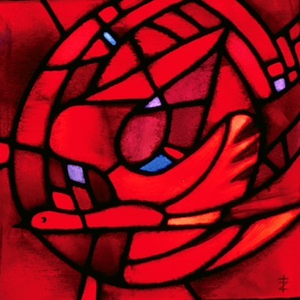

All Welcome
For more information contact
phpaw2@btinternet.com

