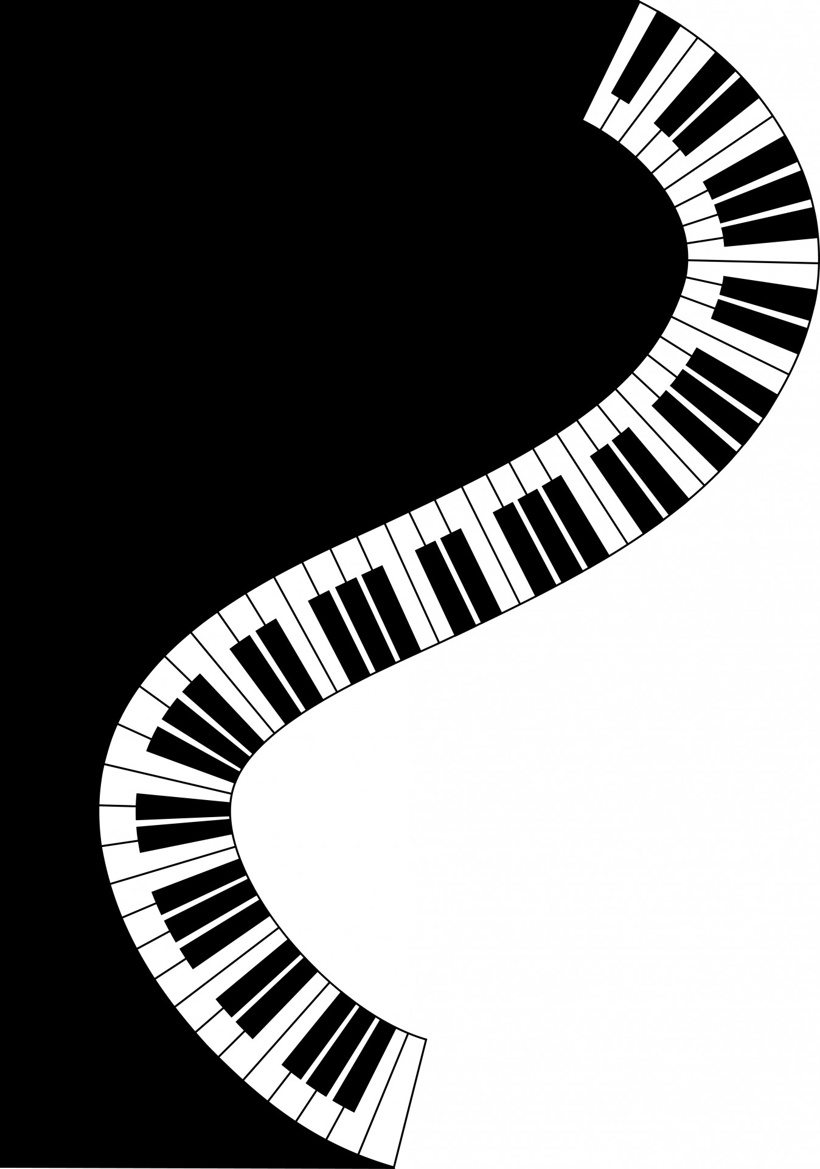
Shirley Methodist Church B90 3AL

Two’s
Harmony
2020 at 2:30pm

Saturday
Keyboard
15th Capers with Graham Lowe and
Jean Hamilton

TICKETS: including tea or coffee,
£7.00 adults, £1.00 children
available from 0121 443 1140,
or at the door.

February Proceeds in aid of church funds

