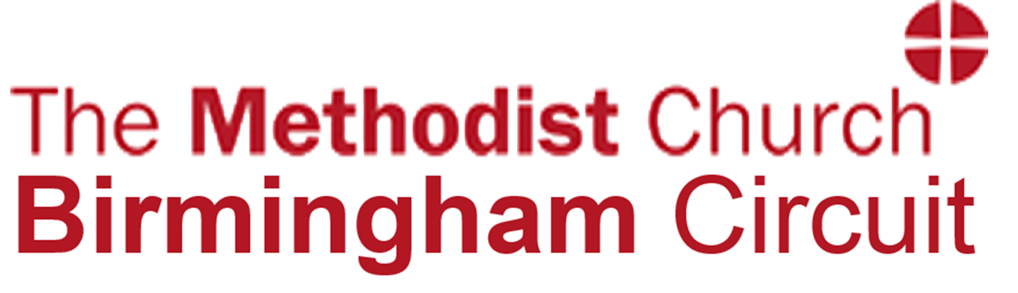

**Prof Jeannette Littlemore (University of Birmingham) and Dr Sarah Turner (Coventry University)**

**Coffee/Tea available from 7:00 pm**

**Thursday 29th November 2018 at 7:30 pm**

**Sponsored by St Mary’s Selly Oak CofE and**

**Selly Oak Methodist Church**

Selly Oak Methodist Church

Langleys Road

B29 6HT

# **‘Death Before Birth: understanding, informing and supporting choices made by people experiencing miscarriage, termination and stillbirth’**

**ADVENT CHALLENGE LECTURE**